**Adding New Sections To Your Library**

Each library has their own sections (unlike subject headings which all libraries share). It is therefore for fine for a library to change the sections of their library without consulting the collective. This can include clicking on existing sections and simply changing what they are called. It can also include creating new sections.

1) First, go to the Admistration tab of PMB at the top right of the page.

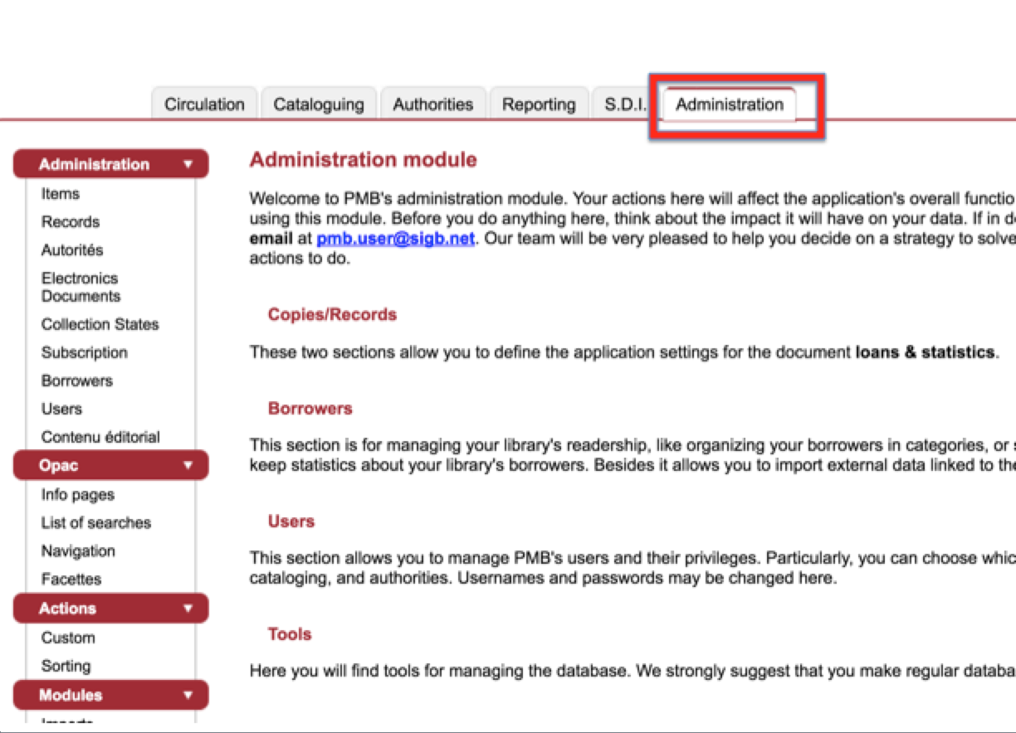

2) Click “items” on under “Administration” on the left of the screen. Then click “sections”.

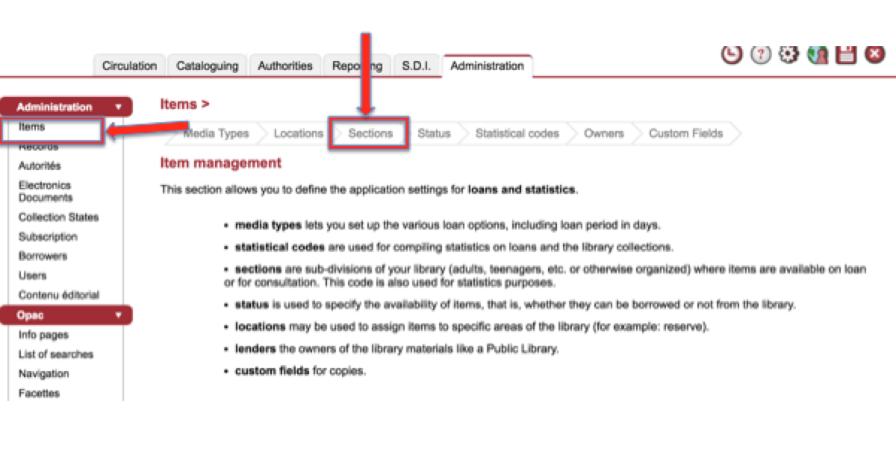

3) Choose the section you want to edit or scroll to the bottom of the page and click “add section”

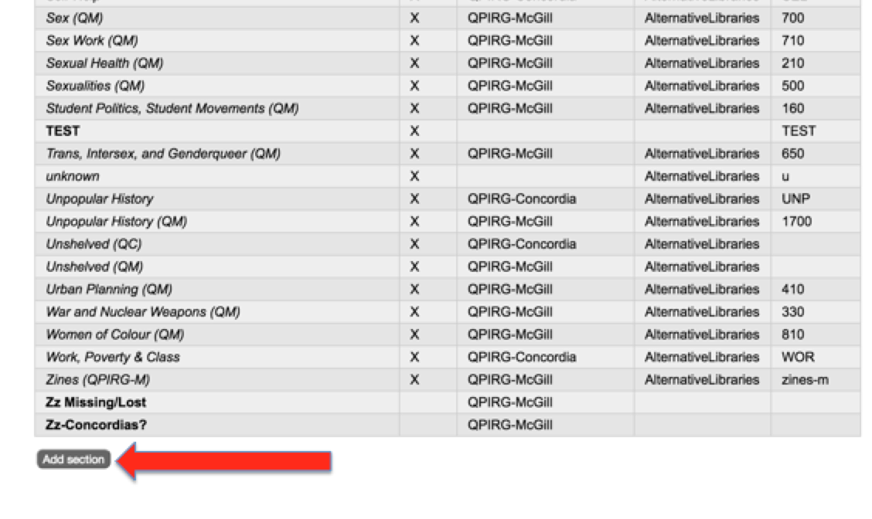

3) Enter the name of the new section. Put the initials of your library beside it as other libraries will likely have similar section names and it’s good to differentiate. Make sure to also click your library’s name from the “visible in location” section. This means when you’re cataloguing, only your sections will show up when assigning sections to items. The “visible in OPAC” is automatically clicked. If you unclick it, users will not be able to see the section on their end. This might be good to do for sections like “Missing”. Just don’t forget those sections are there!

